
Company
Logotype

Cone Beam Computed Tomography- Report



Porur Dental X-rays & CBCT

Patient Name : Mr. Karthik | Date of Report : 10.07.2024
Age/ Gender : 37 years/ Male | Region of Interest : CBCT Sectional Mandible
Referring doctor: Dr. Selvaganesh | Indication : Bone density in relatoion to 32, 33
Clinical Notes: Nil
PATIENT INFORMATION

CBCT- Sectional Mandible provided
CBCT – IMAGE DETAILS

RADIOGRAPHIC INTERPRETATION

- In relation to 31, 32 presence of bone loss extending upto middle third of root and in 32, angular pattern of bone loss extending upto the apical third of the root is evident.
- The alveolar bone in relation to the mandibular ridge is present with normal trabecular pattern.
- Pulp stone in relation to 32 is present.
- Presence of bone loss extending upto 4.78 mm in interdental region of 44, 45, 5.9 mm in interdental region of 45, 46 and 5.89 mm in interdental region of 46, 47 is evident.
- Bone type in relation to 31, 32, 33 is D2 (reference is given in last page).
- Bone density in relation to 31- 374.44 HU
- Bone density in relation to 32- 325.22 HU
- Bone density in relation to 33- 311 HU

RADIOGRAPHIC IMPRESSION

- Chronic generalized periodontitis.

Kindly correlate with clinical findings


IMAGES FOR REFERENCE

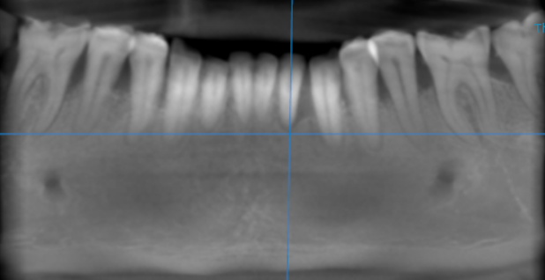

3-DIMENSIONAL VIEW

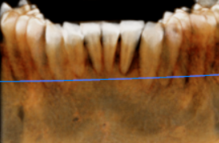

CROSS SECTIONAL VIEW

31, 32, 33 region | 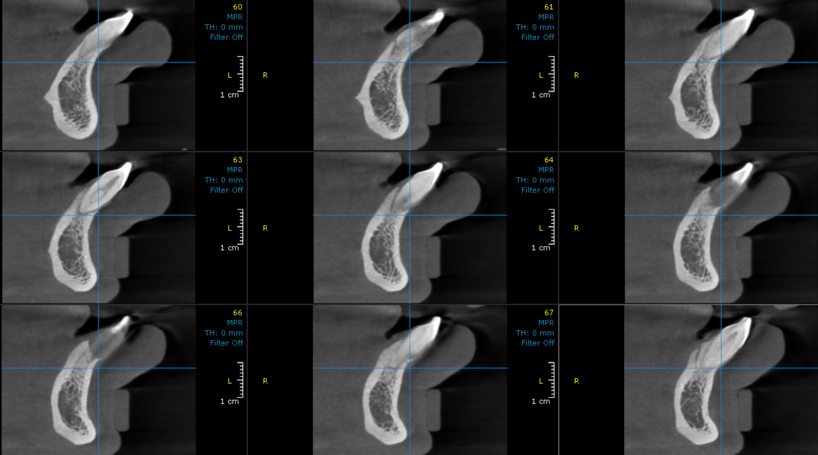

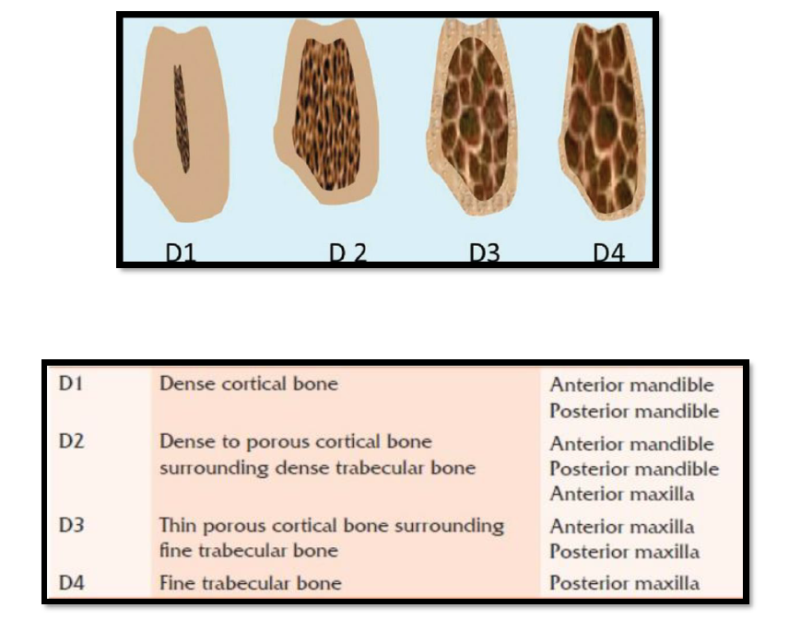
Reference

**** End of report ****

